Appendix 1 Wixford Parish Council Minutes 12th May 2020
County and District Councillor report for ATC 5/5/20
Overview.
The first couple of weeks of lockdown were relatively quiet from a councillor workload perspective with people getting used to the new reality. After that and following the governments measures to support businesses my casework has significantly increased.
Shielding hubs were set up quickly and have been distributing many hundreds of food parcels to very vulnerable people. This has been augmented by the excellent local resilience groups which sprang up almost overnight.
People are now seeing that we are in this for the long haul and social distancing will be with us for many months or years to come.
Life is starting to gain some normality. We have all started using video conferencing and this is now the norm. A new verb in our language is ‘to Zoom’ someone. Many meetings are now carried out this way and it is quite likely that we will never go back to the old system. Large numbers of council officers are working from home and I am pleased to say that the technology has held up in general after some initial wobbles.
In this time County and District councillors were kept fully informed on arising events with regular briefings. I have now sent out over 2 dozen newsletters to groups and councillors.
IT equipment. WCC had recently migrated to new equipment that had already been enabled for remote or agile working. SDC were slightly behind however soon caught up. SDC currently has over 200 staff remote working.
We are experiencing the new way of working even tonight as there may well be a vote. Previously all voting members had to be in the same room. That has changed and local authorities are getting to grips with the new system. I am chairing my first voting meeting at SDC next week. One benefit is that people are not having to travel as much, create less pollution and still getting the work done. This will no doubt carry on.
Health. As the health authority, Warwickshire has performed well. At no time were our intensive care units overloaded, the hospitals did not run out of PPE and working practices were introduced to protect our NHS staff. It has not been easy and the heroic efforts of the NHS are to be warmly applauded.
The rate of residents in Warwickshire catching Covid 19 is around or just below the national average, as are the deaths due to the virus. We need to do more to help those in care homes and although there have certainly been some local issues with PPE, WCC set up a hotline to get urgent supplies to the homes. We do not currently have an ‘red flagged’ homes (meaning they have run out of PPE)
Overall Warwickshire have performed extremely well given the circumstances.
Waste. Our waste has continued to be collected whereas some authorities stopped certain collections like green waste. That has now been resolved and all of Warwickshire now has its normal regular collections. For Stratford, Biffa have performed extremely well. It is hoped that the waste recycling centres will be reopened soon (latest estimate is the 18th May), however, to prevent a rush, the opening is to be coordinated across the county and adjacent authorities.
Businesses. The Government has been very generous in providing a lifeline to small businesses, however a number have slipped through the net. My casework has increased significantly here trying to help out. There are a number of schemes:
- Small business grant scheme. Over 1500 businesses have received a grant of up to £10,000
- Small business loan scheme. Interest free loans for small businesses that do not qualify for the above grant scheme and apply for a loan, interest free for the first year. Interest is then charged at Bank of England rates.
- Grants can be provided through the Self Employment Income support scheme
- The local authority delegated grants scheme has just been announced although details are to follow.
Other items. We have not seen a rise in domestic abuse and that is to be warmly welcomed. There is a caveat in that instances may be being underreported.
We have seen a small increase in ASB
80% of schools are open with around 2% of children of key workers attending.
This is a short rundown on the events of the past 5 weeks.
Cllr Mark Cargill
Alcester Division

Hotlines and areas of concern
I have included a number of phone numbers and links for many of the areas of concern. Please distribute as appropriate. They are designed for social media.

Family Support Duty Phone Line
If you’re finding parenting stressful during #covid19 – you are not alone!
Support and advice on all aspects of parenting is available from the Family Support Duty Helpline on 01926 412412. Lines are open Monday to Friday, 9am to 4pm.
For more information visit https://www.warwickshire.gov.uk/children-families/servicechanges-children-families/2

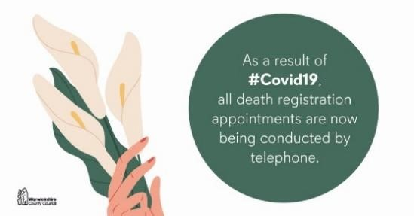

Registration Services – Registering a Birth
As a result of #COVID19, Registration Services are currently not able to register births, but child benefit and universal credit can still be paid. Your questions
answered here: https://www.warwickshire.gov.uk/informationcoronavirus/coronavirus-births-deaths-ceremonies/1
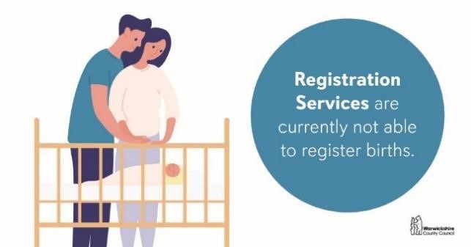

Stop Smoking for ‘Covid19
Smoking makes the impact of coronavirus worse. Quitting smoking is one of the best things that smokers can do for their health right now. Quit now! Need help? See the latest ASH quitting guide:
https://bit.ly/38WDmQv #QuitForCovid #Covid19 @ASH_LDN

Domestic Abuse
Domestic Abuse is happening to men and women across the county #Covid-19.
Refuge, Warwickshire is here for you. Call 0800 408 1552 or email
DVSW@refuge.org.uk In an emergency please call 999. #youarenotalone
